

**Walking on irregular terrain Protocol**

Adriana Torres, CSIC

David Pinto, CSIC

Diego Torricelli, CSIC

**21/10/2021**



This project has received funding from the European Union’s Horizon 2020 research and innovation program under grant agreement No 779963

DOCUMENT HISTORY

|  |  |  |  |
| --- | --- | --- | --- |
| HISTORY OF CHANGES | | | |
| Version | Date | Author | Change |
| 0.1 | xx.xx.2021 | Adriana Torres | 1st version |
| 0.2 | 21.10.2021 | Anthony Remazeilles | Version with Eurobench format |
|  |  |  |  |
|  |  |  |  |

Contents

1 Preparation phase 2

2 Testing phase 2

3 Uneven terrain configurations 3

4 Performance Indicators 4

4.1 Required Performance Indicators 4

4.2 Recommended Performance Indicators 5

4.3 Required observations 6

The protocol consists of a test with multiple trials. The subject should repeat the trial until reaching 10 strides at each uneven terrain configuration, in order to obtain statistically relevant data. The protocol shall be split-up into a preparation and testing phase.

# Preparation phase

It is mandatory to have an enrolment session where the test technician explains the testing phase to the subject and collects the following subject’s data:

* anthropometric data,
* clinical conditions (e.g. health status, neurological disorders, amputations),
* residual abilities (e.g. mental and physical assessment),
* ethical data (e.g. declaration of consent, data protection agreement).

After the enrolment session, it is mandatory to have a familiarization session.

The subject shall conduct the following three familiarization activities prior to the testing phase:

1. Familiarization with the testbed: The subject shall walk without the wearable device on the testbed across the different uneven terrain configurations.
2. Familiarization with the wearable device: The subject shall walk with the wearable device over flat ground (Ground Level Walking (GLW)).
3. Familiarization with the wearable device and the testbed: The subject shall walk with the wearable device on the testbed across the different uneven terrain configurations.

It is recommended to have the preparation phase at least one day before the testing phase.

# Testing phase

The testing phase shall be carried out after the preparation phase.

The testing phase consists of the following steps:

1. The test technician shall instrument the subject with the selected measurement system. The measurement system shall allow the calculation of the required performance indicators (PIs) and should allow the calculation of the recommended PIs.
2. The subject shall perform a trial on ground level walking at self-selected normal speed (SNS) without the wearable device.
3. The test technician shall set up the uneven terrain configuration of the testbed according to the list of uneven terrain configurations that will be tested.
4. The subject shall walk through the testbed at self-selected normal speed (SNS) without the wearable device. The trial at SNS shall be performed first, in order to provide a reference value of the PIs for the subject for the following trials.
5. Step 4 shall be repeated at SNS and, when considered, at self-selected low speed (SLS) and self-selected high speed (SHS). It is recommended to randomize the speed conditions by alternating SNS, SLS and SHS to avoid bias.
6. The subject shall rest for 5 minutes.
7. The test technician, test supervisor and subject shall repeat the protocol steps 3 to 7 for all uneven terrain configurations that will be tested.
8. The subject shall don the wearable device, with the help of the test technician if needed.
9. The test technician shall repeat the protocol steps 1 to 7. These steps will correspond to the “with the wearable device” test condition.
10. The test technician shall support the doffing of the wearable device and measurement system from the subject.
11. The acquired data shall be analyzed and, at least, the required PIs calculated.

# Uneven terrain configurations

The different terrain configurations are the following:

Figure 1 . 5º A-like (A), V-like (B) and M-like (C) configurations.

Figure 2. 10º A-like (A), V-like (B) and M-like (C) configurations.

Figure 3. 15º A-like (A), V-like (B) and M-like (C) configurations.

Figure 4. Steps (A) and Terrasensa (B) configurations

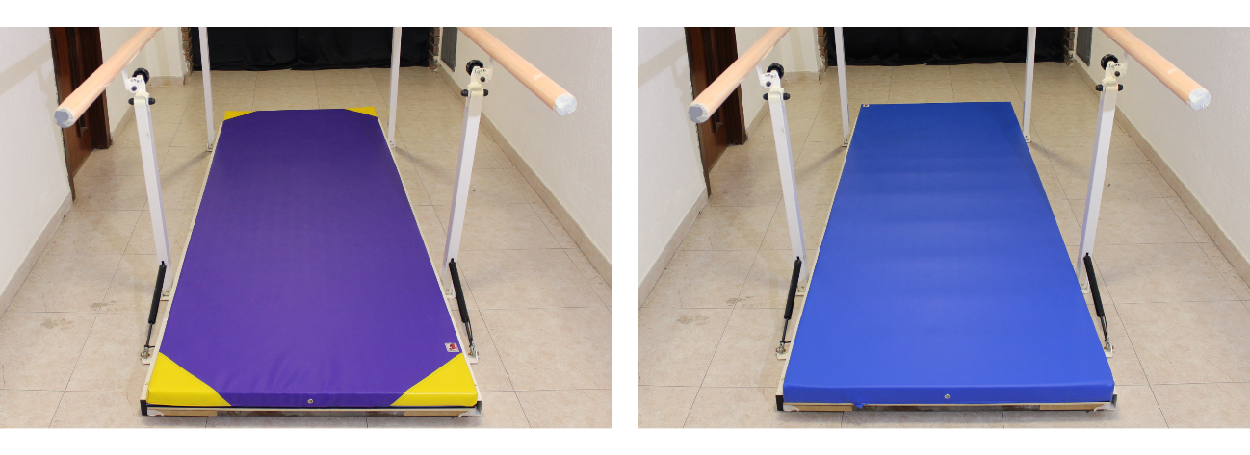

Figure 5. 100kg/m3mat (left) and 30kg/m3mat (right) configurations

# Performance Indicators

## Required Performance Indicators

|  |  |
| --- | --- |
| **Performance Indicator** | **Description** |
| Time to complete | The time that is needed to complete the trial.  Measured in: s. |
| Walking speed | The average walking speed of the subject during completion of the trial. This is calculated by dividing the length of the test bed by the total duration needed to complete the trial.  Measured in: m/s. |
| Cadence | The number of steps the subject makes per minute.  Measured in: steps/min. |
| Stride duration | The time from initial contact of the considered leg until the subsequent initial contact of the same.  Measured in: s. |
| Stance phase duration | Period of time in which the considered leg has contact with the surface.  Measured in: s [or] % of stride duration. |
| Swing phase duration | Period of time in which the considered leg has no contact with the surface.  Measured in: s [or] % of stride duration. |
| Single support phase duration | Period of time that starts with the lifting of the foot of the contralateral leg and ends with initial contact of the contralateral leg. During this phase, the full bodyweight is placed on the considered leg.  Measured in: s [or] % of stride duration. |

## Recommended Performance Indicators

|  |  |
| --- | --- |
| **Performance Indicator** | **Description** |
| Step length | Anteroposterior distance between the heel of the considered leg at initial contact and the heel of the contralateral leg.  Measured in: m. |
| Stride length | Anteroposterior distance between the heel of the considered leg at subsequent initial contacts.  Measured in: m. |
| Step width | Medio lateral distance between the lateral side of the considered foot and the lateral side of the contralateral foot.  Measured in: m. |
| Gait deviation index | The GDI, initially conceived to evaluate the gait of children with cerebral palsy, has been used as a quantitative parameter of gait pattern changes of individuals with other conditions. The GDI quantifies gait motion with a single parameter based on a kinematic data set [3]. It is defined as the scaled distance between 15 gait feature scores for a subject and the average of the same 15 gait feature scores for a control group. A GDI of 100 or higher indicates absence of abnormal gait patterns. If the GDI is lower than 100, each 10 points corresponds to a standard deviation away from the control group mean. |
| Walk ratio | The walk ratio is defined as the division of step length by cadence. It is speed independent and reflects energy expenditure, balance, between-step variability, and attentional demand. In healthy adults, its normal value is around 6.5 mm/ (step/min).  Measured in: mm/ (step/min). |
| Ratio index | The ratio index is used to quantify gait symmetry. It is defined as the division of a gait parameter by the same gait parameter of the contralateral leg. Perfect symmetry is achieved when this parameter equals one. Higher or lower values indicate gait asymmetry. |
| Margins of stability | The margin of stability is a measure of stability during dynamic walking. Walking is defined stable, if the position of the extrapolated center of mass position (XcoM) is within the base of support (BoS).  =+/CoMCoMVXCoMPgl  where  PCoM is the vertical projection of the center of mass,  VCoM is the velocity of the center of mass,  g is the acceleration of gravity,  l is the leg length.  The margin of stability should be expressed using the backwards margin of stability (BMoS) and the mediolateral margin of stability (MLMoS). The BMoS is defined as the minimal distance between the XCoM and the BoS in the anteroposterior direction during the stance phase. The MLMoS is defined as the minimal distance between the XCoM and the BoS in the mediolateral direction during the stance phase.  BMoS = minstance (XCoMx – BOSx)  MLMoS = minstance (XCoMy – BOSy)  where  minstance is the minimal distance during the stance phase,  XCoM is the extrapolated center of mass position,  x is the anteroposterior direction,  BoS is the base of support,  y is the mediolateral direction.  Measured in: m. |

## Required observations

|  |  |
| --- | --- |
| **Observation** |  |
| Number of handrail touches | The number of times the subject touches the handrail during completion of the trial. In case a subject uses the handrail continuously, this observation shall be quantified as the total duration of continuous contact.  Measured in: integer number [or] seconds. |
| Successful execution | Whether the subject has completed the trial.  Measured in: binary (0=failed, 1=succeeded). |
| Number of stumbles | The number of balance perturbations that occur during the completion of the trial. Balance perturbations can be detected either by visual inspection or by measuring alterations in the kinematics or kinetics.  Measured in: integer number. |